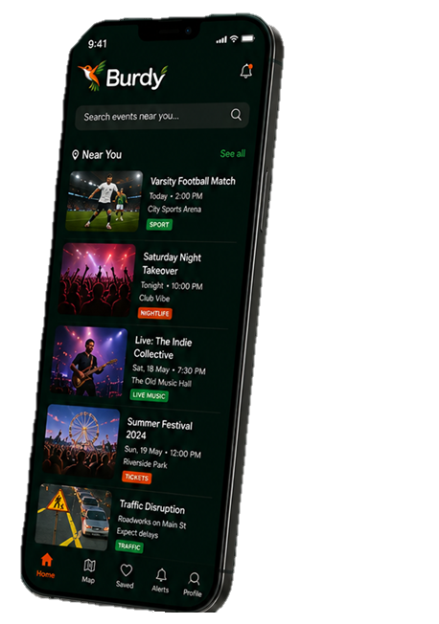














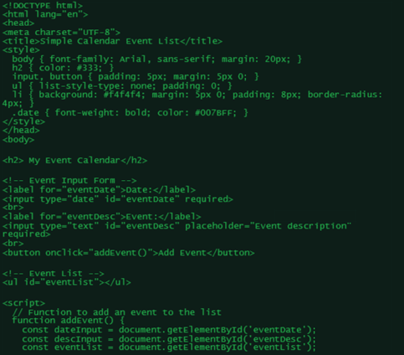







ALL IN ONE APP.
NEVER MISS OUT.
ALL THE EVENTS.
LIVE INSIGHTS AND UPDATES
100+ CATEGORIES COVERED
50,000+ VENUES AND BUSINESSES
1,000,000+ EVENTS TRACKED
IN PARTNERSHIP WITH
ALL THE EVENTS. IN ONE APP.

